**Machine Learning Approach for Detection of Cyber-Aggressive Comments by Peers on Social Media Network**

**Methodologies**

**Pre-Processing**: Normalization like: removing unwanted strings and correcting words.

**Features**: N-gram , TF-IDF , occurrence of pronouns , Skip-gram

**Classifiers**: Support Vector Machine (SVM) , Logistic Regression

**Results**

70.0% Precision and 77.65% Acc. using SVM

64.0% Precision and 73.76% Acc. using logistic regression

**Drawbacks:**

**N-gram:** the size tends to be large, and the performance of queries especially, long ones tends to be bad [18, 9]. These drawbacks stem from the method of extracting terms, that is, the 1-sliding technique.

**TF-IDF:**

– It computes document similarity directly in the word-count space, which may be slow for large vocabularies.

– It assumes that the counts of different words provide independent evidence of similarity.

– It makes no use of semantic similarities between words.

**Skip-gram:**

The disadvantage of skip-gram modelling is the sheer size of the training model that can be produced. This can lead to a large increase in processing time that should be leveraged against the time taken to extend the size of the training corpus.

**Logistic regression:**

logistic regression cannot predict continuous outcomes. For example, logistic regression could not be used to determine how high an influenza patient's fever will rise, because the scale of measurement -- temperature -- is continuous.

**SVM:**

the most serious problem with SVMs is the high algorithmic complexity and extensive memory requirements of the required quadratic programming in large-scale tasks.

**Sentiment Informed Cyberbullying Detection in Social Media**

-Their framework is called SICD

**Methodologies**

**Pre-Processing**: Stopwords removal and stemming.

**Features**: TF-IDF

**Classifiers**: KNN

**Results**

**F1**: 0.6105 **AUC**: 0.7539 using SICD

**Drawbacks:**

**Knn:**

The main disadvantage of this approach is that the algorithm must compute the distance and sort all the training data at each prediction, which can be slow if there are a large number of training examples. Another disadvantage of this approach is that the algorithm does not learn anything from the training data.

**Sarcastic sentiment detection in tweets streamed in real time**

In this paper the author discussed how it's hard for humans to detect sarcastic comments and the amount

of data is huge for manual detection. The author proposed a framework that recieve tweets

and process them to identify sarcastic comments. The hadoop-based framework allows user to

get and save tweets and process them. They used Twitter streaming API(twitter4j) to retieve

tweets. They used sentiment analysis to classify the tweets as negative, positive or neutral.

The tweets pass through MapReduce functions for sentiemnt classification.

they used parts-of-speach(POS) for deviding sentences into words and assign appropriate information

and they used parsing to analyze grammatical structure. Finally, they used 6 algorithms and achieved

0.97 precision when the combined 3 of them. They are: Parsed based lexicon generation algorithm(PBLGA),

Interjection word start(IWS),Postive sentiment with antonym pair(PSWAP).

**Cyberbullying Detection A Step Toward a Safer Internet Yard**

**Summary**

They used SVM model in WEKA(data mining software) for classification and they used Mypes service that allows the aggregation of users’ profiles so they can link users on multi social media platforms. The authors talked about how serious cyberbullying is, they hypothesized that the use of user’s information is essential for more precise detection like: age and gender. They calculated the ratio of profane words and the ratio of pronouns in each post then used as features along with TFIDF.

**Methodologies**

Classifiers: SVM

Features: TFIDF, Age and Gender

Tools: Mypes and WEKA

**Dataset**

The data-set is provided by Fundacion Barcelona Media collected from MySpace it’s size is 381,000 posts, the ground truth data-set is 2,200 labeled by three students.

**Accuracy**

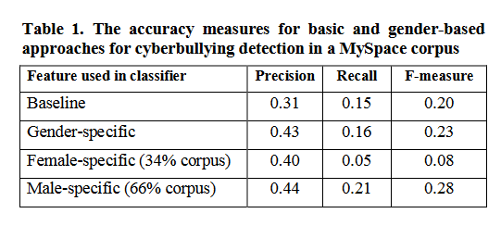

**Drawbacks**

The ground truth data-set is to small to training the classifier.

They didn’t use sentiment analysis

**Online Social Network Bullying Detection Using Intelligence Techniques**

**Summary**

**Methodologies**

**Accuracy**

**Drawbacks**